IRF22/847

Planning Proposal PP-2021-406
Callala Bay, Wollumboola and Kinghorne Halloran Trust Lands (Rezoning)
March 2022

Published by NSW Department of Planning and Environment
dpie.nsw.gov.au
Title: Planning Proposal PP-2021-406
Subtitle: Callala Bay, Wollumboola and Kinghorne Halloran Trust Lands (Rezoning)
© State of New South Wales through Department of Planning and Environment 2022 You may copy, distribute, display, download and otherwise freely deal with this publication for any purpose, provided that you attribute the Department of Planning and Environment as the owner. However, you must obtain permission if you wish to charge others for access to the publication (other than at cost); include the publication in advertising or a product for sale; modify the publication; or republish the publication on a website. You may freely link to the publication on a departmental website.
Disclaimer: The information contained in this publication is based on knowledge and understanding at the time of writing [March 22] and may not be accurate, current or complete. The State of New South Wales (including the NSW Department of Planning and Environment), the author and the publisher take no responsibility, and will accept no liability, for the accuracy, currency, reliability or correctness of any information included in the document (including material provided by third parties). Readers should make their own inquiries and rely on their own advice when making decisions related to material contained in this publication.

Acknowledgment of Country
The Department of Planning and Environment acknowledges the Traditional Owners and Custodians of the land on which we live and work and pays respect to Elders past, present and future.

Contents
1 Introduction 2
Overview 2
Subject Land 2
Background to the planning proposal 4
2 Planning Proposal 4
Part 1 – Objectives or intended outcomes 4
Part 2 – Explanation of provisions 6
Part 3 – Justification 7
Section A – Need for the Planning Proposal 7
Section B – Relationship to strategic planning framework 9
Section C – Environmental, social and economic impact 24
Section D – State or Commonwealth interests 27
Part 4 – Mapping 29
Part 5 – Community consultation 36
Consultation undertaken to date 36
Formal public exhibition of the Planning Proposal 36
Part 6 – Project timeline 37
3 Attachments 38

Introduction

Overview
The planning proposal (PP) seeks to amend the Shoalhaven Local Environmental Plan (LEP) 2014 to facilitate delivery of additional housing and to preserve the environmental values of certain land owned by the Halloran Trust in the Callala Bay, Wollumboola and Kinghorne localities – Refer to Attachment A.
As part of the PP, the subject land will be incorporated into the Shoalhaven LEP 2014. This land is mostly identified as a ‘deferred matter’ and is subject to the provisions of the Shoalhaven LEP 1985.
Approximately 517 hectares of land will be preserved under C2 Environmental Conservation zoning and will ultimately be incorporated into the Jervis Bay National Park. An additional 2 hectares of bushland will also be preserved to protect a population of the endangered Bauer’s Midge Orchid (Genoplesium baueri).
The PP will also support the delivery of up to 380 additional homes.

Subject Land
This PP applies to land owned by Sealark Pty Ltd in the Callala Bay and Kinghorne localities within the Shoalhaven Local Government Area (LGA), approximately 18 km south-east of Nowra (see Figure 1 and Figure 2).
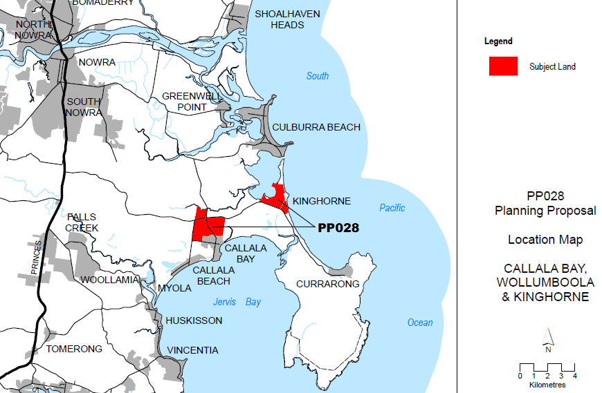
PP-2020-406
PP-2020-406
Figure 1: Location Map (Source: Shoalhaven City Council, 2021)
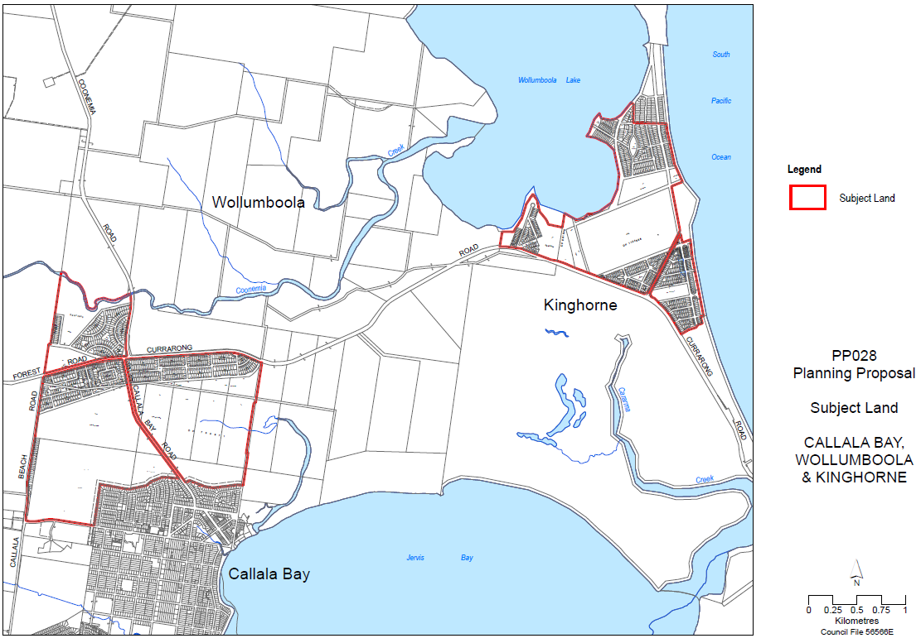
Figure 2: Subject land (Source: Shoalhaven City Council, 2021)
The PP also includes some small areas of Council-owned land associated with Council infrastructure, and some land being acquired by Council associated with the road network. A detailed table of the individual allotments affected by this PP is provided at Attachment A.
The subject land is mainly covered by native vegetation, with some areas in Kinghorne partially cleared for former rural purposes.
In Callala Bay, a partially cleared corridor approx. 40 metres wide separates the northern edge of the existing residential area from the bushland to the north. This area was set aside for bushfire protection as part of the subdivision in the 1980s and is currently owned and maintained by the proponent.
This corridor forms part of the subject land and is proposed to be retained as a ‘linear reserve’ and dedicated to Council for bushfire management and as a pedestrian and cyclist link between the development area and the coastline.
The development area
The proposed overall development area (Figures 3 and 4) is approximately 40 hectares (including reserves) and is bounded by Callala Beach Road to the west, the existing Callala Bay residential area (off Stott Crescent) to the east, Emmett Street to the south, and the Lake Wollumboola Biobank Site to the north.
The development area slopes gently to the south and south-east toward Callala Creek which flows east into Jervis Bay between the Callala Beach and Callala Bay localities. No watercourses traverse the site.
The development area is primarily proposed to be rezoned for residential purposes but will also include:
- a protect approximately 2 hectares of land as a bushland reserve, containing a population of the threatened species, known as the Bauer’s Midge Orchid;
- a linear reserve on the lands northern edge, and
- a 20m wide vegetation buffer adjacent to Callala Beach Road and the western end of Emmett street.

Background to the planning proposal
The land subject to this PP was initially part of a larger PP that also included land owned by the Halloran Trust at Culburra Beach. The larger PP (including land at Callala Bay, Wallumboola, Kinghorne and Culburra) received its Gateway Determination in November 2015.
Technical studies following the Gateway determination identified the need to undertake additional groundwater investigations and monitoring of the land at Culburra Beach related to water drainage into Lake Wollumboola. This requirement had resulted in delays to the progression of the larger PP.
On 12 September 2017, Council resolved to split the larger PP into two separate PPs. This allowed the Callala Bay, Wollumboola and Kinghorne areas to progress while the Culburra Beach area continued ongoing environmental investigations.
A Gateway determination for the land subject to this PP (Callala Bay, Wollumboola and Kinghorne areas only), was issued with conditions on 13 June 2018 and was altered on 18 June 2020 to allow an extended timeframe for completion (December 2021).
Following an assessment of the progress of the PP, the former Minister for Planning and Public Spaces confirmed in December 2021 that the PP is of regional significance and that its finalisation is in the public interest.
To support the acceleration of the PP in progressing to public exhibition and finalisation, the Minister determined the Department would take on responsibility from Council as the Planning Proposal Authority (PPA) to ensure the PP is finalised by mid-2022.
The Department and Council are working together to deliver the public exhibition of the PP. The Department will undertake a finalisation assessment following the completion of public exhibition, including the review and consideration of any public and/or agency submissions.

Planning Proposal
Section 3.33(2) of the Environmental Planning and Assessment Act 1979 (the Act) outlines requirements that must be provided for when preparing PPs. The following sections provide details of the PP as it relates to Section 3.33(2) of the Act.

Part 1 – Objectives or intended outcomes
The intended outcome is to amend the Shoalhaven LEP 2014 to:
- facilitate new housing development on the western edge of Callala Bay, consistent with strategic growth plans; and,
- protect biodiversity values across the remainder of the subject land through environmental zoning, conservation agreements and by adding land to the Jervis Bay National Park Estate.
Figure 3 highlights where new housing development is proposed and where land is to be protected due to its environmental significance under each objective.
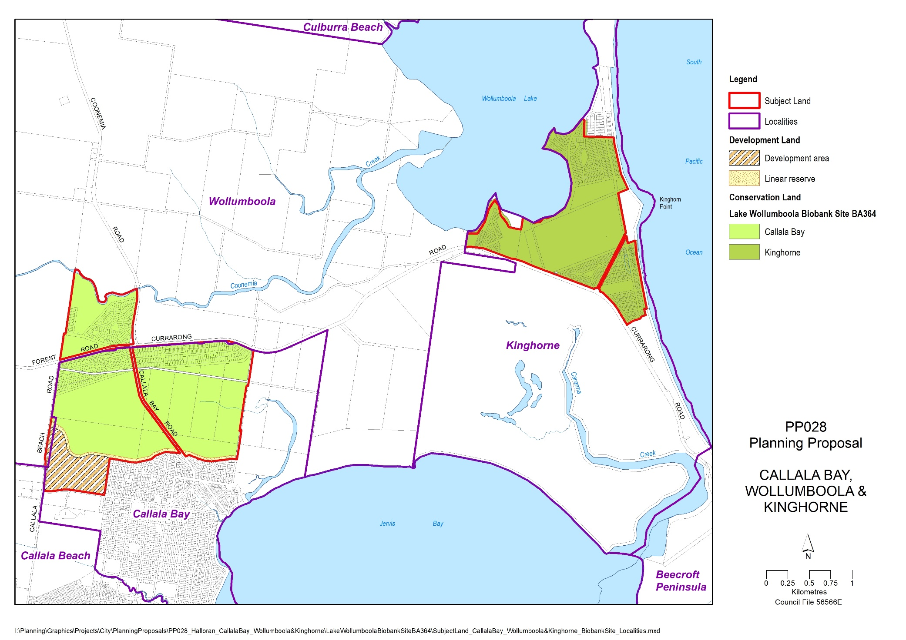Figure 3 – Proposed development and conservation areas (Source: Shoalhaven City Council, 2021)
The wide-ranging aims of this PP are grouped into the following environmental, social and economic objectives.
Environmental objectives
- Conserve the habitats of native flora and fauna species and communities, especially those that are threatened or endangered.
- Mitigate impacts of vegetation removal for development.
- Protect water quality and the ecology of Lake Wollumboola and the Jervis Bay Marine Park.
- Establish effective planning and land management mechanisms to protect environmentally and culturally significant landscapes;
- Make efficient use of scarce land resources and locate new housing adjacent to Callala Bay close to existing services.
Social objectives
- Plan for a new, high-amenity residential neighbourhood in Callala Bay that respects the character of the town and the surrounding bushland setting.
- Mitigate risks associated with natural hazards (e.g. bushfire, heatwaves, storms and flooding).
- Promote healthy lifestyles through encouraging walking and cycling and providing public open spaces and recreation opportunities.
- Enable a range of housing types and sizes to promote greater housing affordability.
- Involve the local community and Traditional Custodians in planning for the area.
Economic objectives
- Support growth and jobs in the town centre by growing the local resident population.
- Ensure required infrastructure is funded, delivered and maintained to align with development need in a cost-effective manner.
- Consider development feasibility to promote the timely and efficient release of land for development and associated infrastructure.
The area also contains hundreds of lots within ‘paper subdivisions’, which were subdivided in the 1920s by Henry Halloran but never physically developed nor serviced by infrastructure. These lots cannot be developed for housing under current planning controls. This PP will facilitate the incorporation of these paper subdivision lots, along with the proponent’s surrounding land, into the Jervis Bay National Park, consistent with the Jervis Bay Settlement Strategy 2003.

Part 2 – Explanation of provisions
The PP seeks to incorporate the subject land into the Shoalhaven LEP 2014, which will remove the ‘Deferred Matter’ status applying to the land. In doing so, the following changes to the Shoalhaven LEP 2014 are proposed under this PP:
- amend the Land Use Zoning map for certain land identified as ‘Deferred Matter’ to C2 Environmental Conservation, C3 Environmental Management, R1 General Residential, SP2 Infrastructure and RE1 Public Recreation;
- amend the Land Use Zoning map for certain land zoned RU2 Rural Landscape to SP2 Infrastructure, R1 General Residential and C2 Environmental Conservation;
- amend the Minimum Lot Size map to apply a minimum lot size of:
  - 500sqm for land zoned R1 General Residential;
  - 2 hectares for land zoned RE1 Public Recreation;
  - 40 hectares for land zoned C2 Environmental Conservation and C3 Environmental Management;
- amend the Height of Buildings map to apply a maximum building height of 8.5m for land zoned R1 General Residential;
- amend the Urban Release Area map to identify the development area only;
- amend the Clauses map to apply clause 7.20 “Development in the Jervis Bay region” of the Shoalhaven LEP 2014 to land subject to this PP;
- amend the Acid Sulfate Soils map to identify suitable classes applicable to the land subject to this PP;
- amend the Terrestrial Biodiversity map to identify the portion of site comprising of threatened ecological communities;
- amend the Riparian and Watercourses map to identify a portion of the site as comprising of riparian land; and
- amend the Land Application Map to include the land subject to this PP.
The map sheets proposed to be amended by this PP are outlined in Part 4 and are included, as well as a comparison between existing and proposed maps, as Attachment B. The provisions outlined above seek to facilitate the delivery of a preliminary masterplan for the development area in Figure 4 (Attachment Q). The masterplan has not been approved by Shoalhaven City Council, is indicative only and any development will require detailed assessment at the development application stage.
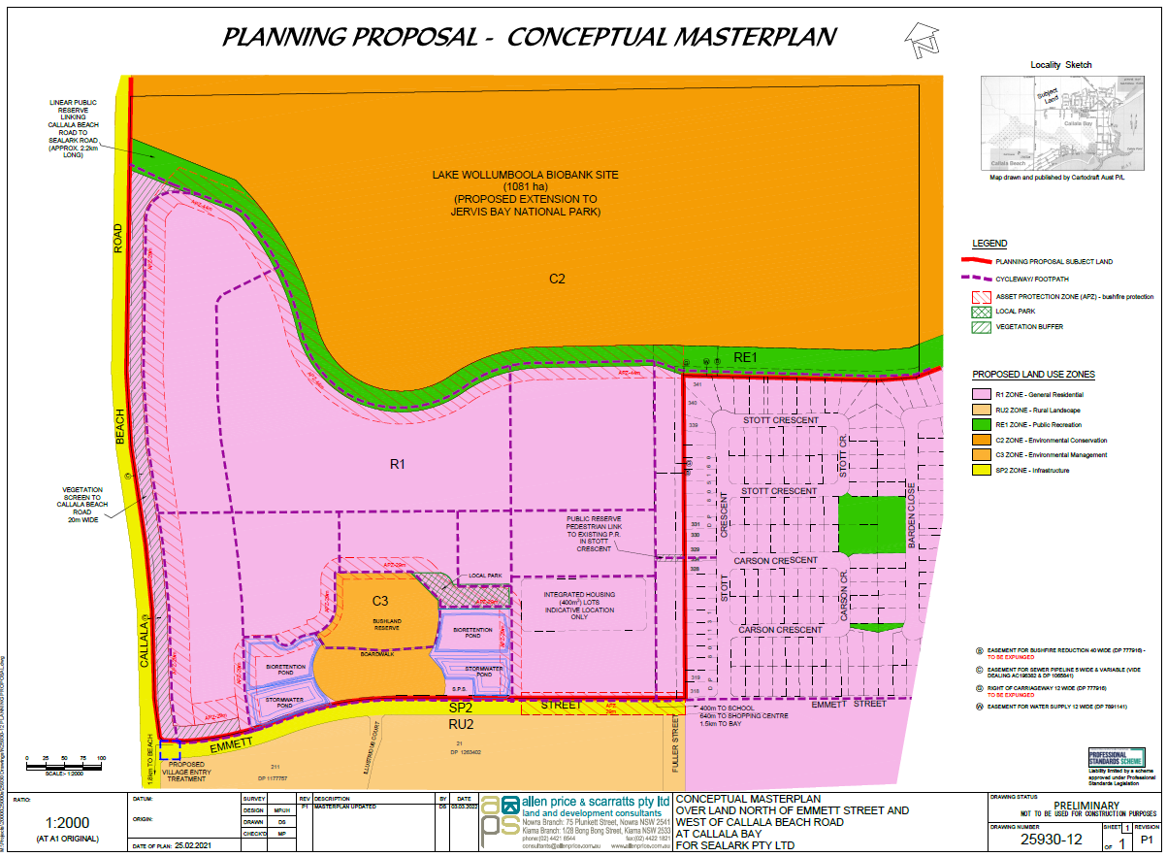
Figure 4 – Callala Bay PP Masterplan (Source: Allen Price & Scarratts Pty Ltd, 2022)
The amendments to the Shoalhaven LEP 2014 will be supported by:
- A site-specific chapter in the Shoalhaven Development Control Plan (DCP) 2014;
- An amendment to the Shoalhaven Contributions Plan 2019 to ensure growth is supported by adequate infrastructure – i.e. that development contributions from the subject land align with the associated increased demand on services; and
- A Planning Agreement outlining the public spaces to be provided and embellished by the developer and then dedicated to Council, including the provision of funds for ongoing maintenance of these areas. These public spaces include the bushland reserve (set aside for protection of threatened species), a vegetation screen along Callala Beach Road and the western end of Emmett Street, and the northern linear reserve (set aside for a pedestrian and cycle link and for bushfire hazard management).
The amendments to the Shoalhaven DCP 2014, the Shoalhaven Contributions Plan 2019, and the execution of a Planning Agreement will be coordinated by Council as a separate process to the PP.

Part 3 – Justification

Section A – Need for the Planning Proposal
Question 1 – Is the Planning Proposal a result of an endorsed Local Strategic Planning statement (LSPS), strategic study or report?
Yes – The PP gives effect to a specific action in the Jervis Bay Settlement Strategy 2003 (JBSS) prepared by Shoalhaven City Council and endorsed by the NSW State Government in 2003. The proposed residential area is identified in the JBSS as an investigation area to:
“provide for possible expansion of the settlement to the west and resolve the existing small lot rural subdivision (intersection of Coonemia/Currarong Roads) in association with any rezoning.”
Figure 5 identifies the application of this action from JBSS 2003.
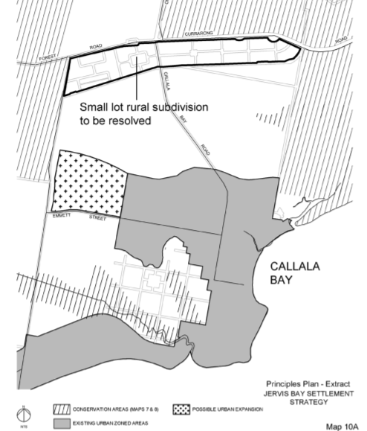
Figure 5 –Callala Bay potential urban expansion area (the proposed development area outlined in Red) (Source: Extract from JBSS 2003)
Over the past 25 years, the subject land (as a whole or in part) has also been the subject of a range of planning documents/assessments, including:
- Jervis Bay Regional Plan 1996 – now repealed with provisions incorporated into Shoalhaven LEP 2014;
- Independent studies/inquiries into Lake Wollumboola and its catchment (1999 COI; Healthy Rivers Commission; South Coast Sensitive Urban Lands Review, October 2006; Scanes Peer Review 2013, HGEO groundwater assessment August 2020);
- Shoalhaven Growth Management Strategy 2014; and
- Illawarra-Shoalhaven Regional Plan 2016-2036 – and the updated Illawarra-Shoalhaven Regional Plan 2041.
The high ecological significance of Lake Wollumboola is consistently expressed in the above studies and strategies. This PP is consistent with the above assessments/documents as it seeks to rezone the land within the Lake Wollumboola water catchment, along with other environmentally sensitive land, to C2 Environmental Conservation zone. The PP will also facilitate the addition of this land to the Jervis Bay National Park (via Biobank and Biodiversity Certification agreements between the landowner and NSW State Government).
Question 2 – Is the Planning Proposal the best means of achieving the objectives or intended outcomes, or is there a better way?
The PP seeks to introduce planning controls to the land under the Shoalhaven LEP 2014 and will guide future development and land conservation under the Act. The PP is considered the best way to achieve the objectives outlined in Part 1 – Objectives or intended outcomes. This is because it:
- is the relevant planning mechanism to rezone land, including to resolve the ‘Deferred Matter’ status of the land;
- will allow for the delivery of additional housing to the west of the existing Callala Bay township, as well as allocating large areas for environmental conservation in perpetuity by amending the Land Use Zoning map; and
- utilises existing local provisions and LEP map sheets to apply supplementary planning controls to the subject land, that support the efficient and equitable use of land for residential and environmental conservation purposes.
Development controls that are not required to be identified under the Shoalhaven LEP 2014 (i.e. design related controls), will be supported by a site-specific DCP Chapter. Additional mechanisms such as a Planning Agreement and Development Contributions Plan updates, to be developed after the land is rezoned, will support beneficial development outcomes for future residents and the wider community.

Section B – Relationship to strategic planning framework
Question 3 – Will the Planning Proposal give effect to the objectives and actions of the applicable regional, or district plan or strategy (including any exhibited draft plans or strategies)?
Illawarra Shoalhaven Regional Plan 2041 (the Region Plan)
The Regional Plan applies to the Shoalhaven LGA and was released in May 2021. It provides regional level guidance on a range of strategic planning matters. The Regional Plan comprises four themes and 30 objectives. The objectives are supported by nine actions, 61 strategies and nine collaboration activities that will help to deliver the vision for the Illawarra Shoalhaven Region.
The PP is broadly consistent with the priorities of the Region Plan and an assessment of the proposal against the relevant objectives and strategies in this plan is provided below.
Table 1: Assessment of the Region Plan
Objective/Strategy | Comment
Theme 1: A productive and innovative region
Objective 2: Grow the region’s regional cities | Nowra is recognised as a regional city. Callala Bay is located within an approximate 20 minute drive and residents are likely to visit Nowra for higher-order services, entertainment and employment, assisting in activation of Nowra City Centre. Growth will also provide funding for infrastructure improvements via contributions levies.
Objective 5: Create a diverse visitor economy  Strategy 5.1 Principles to enhance places and culture, protect heritage and the environment and promote eco-tourism  Strategy 5.2 Support visitor economy in national parks | The PP will facilitate the addition of state and regionally significant land to the Jervis Bay National Park.
Objective 8: Strengthen the economic self-determination of Aboriginal communities  Strategy 8.1 Partner with Aboriginal communities  Strategy 8.4 Provide opportunities for Local Aboriginal Land Councils (LALC) to utilise the NSW planning system to achieve development aspirations | There may be opportunities to explore economic, employment and/or eco-tourism related opportunities in collaboration and partnership with local Aboriginal communities as part of the addition of land to the Jervis Bay National Park.  The PP will also provide an opportunity for engagement with Jerrinja LALC as part of the consultation process to determine broader planning considerations and aspirations as it relates to the site.
Theme 3: A sustainable and resilient region
Objective 11: Protect important environmental assets  Strategy 11.1 Recognise the validated high environmental value lands in LEPs, apply minimise, avoid, offset hierarchy.  Strategy 11.2 Protect and enhance the function and resilience of biodiversity corridors.  Strategy 11.3 Consider the needs of climate refugia  Strategy 11.4 Protect biodiversity values in urban release areas  Strategy 11.5 Protect coastal lakes and estuaries by implementing the NSW Government’s Risk- Based Framework for Considering Waterway Health Outcomes in Strategic Land-use Planning Decisions. | The PP will facilitate the protection of land within the catchments of Lake Wollumboola and Jervis Bay by rezoning it to C2 Environmental Conservation and facilitating its addition to the Jervis Bay National Park.  The proponent’s Integrated Water Cycle Management Study describes water sensitive urban design (WSUD) measures to be incorporated into the proposed expansion of the Callala Bay residential area, to help protect the downstream water quality in the Jervis Bay Marine Park and associated waterways.  A 2 ha bushland reserve is proposed within the residential area which seeks to protect a population of endangered orchids (Bauer’s Midge Orchid).  Engagement with relevant State agencies will inform the final PP to ensure conservation outcomes are implemented for the subject land in the current and future planning processes.
Objective 12: Build resilient places  Strategy 12.1 Resilience and adaptation plans  Strategy 12.2: Reduce exposure to bushfire and natural hazards | The site-specific DCP that will be prepared by Council to support the PP can promote greater resilience in development output through use of sustainable energy, building design and materials.  The PP supports the emergency preparedness for the Callala Bay township through asset protection zones and through proposed improvements to the existing fire trail to the north of the existing subdivision.  A bushfire hazard assessment accompanies the PP and consultation with NSW Rural Fire Service has informed the exhibited PP. The proposed residential area is not flood-affected and is not affected by coastal hazard risks.
Objective 13: Increase urban tree canopy cover | Although the proposal will result in a net loss of tree canopy, new public open spaces are proposed which will provide increased urban tree canopy cover. The site-specific DCP supporting the PP can promote an increased urban tree canopy target for the subdivision, as well as promote opportunities for greater deep soil zones, water sensitive urban design (WSUD) and landscaping requirements to contribute to urban greening. Measures introduced will be prepared in accordance with State planning policies and the draft NSW Greener Places Guide.
Objective 14: Enhance and connect parks, open spaces and bushland with walking and cycling paths.  Strategy 14.1: plan for urban release areas to supply a sufficient quantity and quality of new accessible open space | Provision of suitable public open space and walking and cycling links as part of the new Urban Release area is a key objective of the proposed masterplan for the site and is reflected in the proposed zoning maps. The site-specific DCP can provide guidance and specifications on the provision of local infrastructure such as public open space and active transport connections.  Further updates to the Infrastructure Study reflect the need to satisfy this objective and strategy (supply of sufficient quantity and quality of new accessible open space) at the rezoning stage of development.
Objective 15: Plan for a Net Zero region by 2050  Strategy 15.1 Strategic planning and local plans should consider opportunities to encourage initiatives that reduce emissions  Strategy 15.2 Local plans should encourage energy efficient design for residential areas. | The proposed residential area is within walking and cycling distance of local services at Callala Bay, consistent with the goal of reducing transport emissions (reducing frequency of car trips to access local facilities, recognising higher order services will require private transport until public transport or low emission vehicle transport is provided).  The site-specific DCP can encourage energy efficient subdivision and building design in accordance with State planning policies and the draft Design and Place SEPP.
Objective 17: Secure water resources | The proponent’s Integrated Water Cycle Management Study describes WSUD measures proposed to be integrated into the residential area to help protect receiving waterways in the Jervis Bay Marine Park.  The site-specific DCP can provide specific guidance on the integration of development and stormwater infrastructure. In addition, current State planning policies such as State Environmental Planning Policy (SEPP) (Building Sustainability Index: BASIX) 2004 includes provision to ensure residential development achieves necessary water targets to promote the efficient and equitable use of resources.
Theme 3: A region that values its people and places
Objective 18: Provide housing supply in the right locations | The proposed residential area is identified as a potential residential expansion area in the endorsed JBSS 2003. This land adjoins the existing Callala Bay town and is within walking distance to local services.
Objective 19: Deliver housing that is more diverse and affordable  Strategy 19.1 provide a mix of housing types and lot sizes including small lots in urban release areas | The proposed R1 General Residential would allow some small lot development and diverse housing types consistent with this objective.
Objective 21: Respond to the changing needs of local neighbourhoods  Strategy 21.1 improve public space, in consultation with the community, to foster and support connectivity and great places to live for changing populations. | Consistent with Objective 14, the provision of suitable public open space and walking and cycling links as part of the new Urban Release area is a key objective of the proposed masterplan for the site and is reflected in the proposed zoning maps. The site-specific DCP can provide guidance and specifications on the provision of local infrastructure such as public open space and active transport connections.  The public exhibition of the PP and any future Development Application (DA) will provide the opportunity for public comment on the services being provided to support current and future communities.
Objective 22: Embrace and respect the region’s local character | The PP and site-specific DCP together will seek to shape future development that respects the character of the area – for example through zoning and height limits; providing a 20 m wide vegetation screen between Callala Beach Road and new development and encouraging generous public and private landscaped areas consistent with the bushland setting.
Objective 23: Celebrate, conserve and reuse cultural heritage  Strategy 23.1 Strategic planning should consider opportunities to engage Traditional Owners and the community early in the planning process to understand heritage values. | The Jerrinja Local Aboriginal Land Council will be consulted as the PP progresses, consistent with the Gateway Determination.
Theme 4: A smart connected and accessible region
Objective 28: Create connected and accessible walking and cycling networks | The proponent is proposing a comprehensive network of shared user paths and footpaths, consistent with this objective, including a shared path along the northern linear reserve connecting the development area to the coastline (Figure 4). Council is working with the proponent to ensure these path networks align with Council’s strategies such as its Pedestrian Access and Mobility Plan. These details will be refined as part of the site-specific DCP that will be prepared after the PP is finalised.

Question 4 - Will the planning proposal give effect to a council’s endorsed local strategic planning statement, or another endorsed local strategy or strategic plan?
Local Strategic Planning Statement (LSPS) - Shoalhaven 2040 – Strategic Land-use Planning Statement
Council’s LSPS was adopted on 29 September 2020 and identifies the land-use planning and related work Council needs to do to meet the communities’ needs over the next 20 years. The PP is generally consistent with the themes and planning priorities of the LSPS as highlighted below:
- Planning Priority 1 – Providing homes to meet needs and lifestyles
The PP will increase the availability and diversity of housing and add to the supply of homes in an identified growth area
- Planning Priority 3 – Providing jobs close to home
The PP will provide work to sustain local jobs in construction as well as supporting local businesses and tourism jobs associated with Jervis Bay National Park and Marine Park.
- Planning Priority 10 Protecting the environment
The PP will support the protection of environmentally sensitive land within the development area and surrounding Lake Wollumboola.
- Planning Priority 11 Adapting to natural hazards
The inclusion of asset protection zones and improvements to fire trail(s), among other measures, will support in building the resilience of the Callala Bay township to bushfire hazards. These measures will be incorporated into the stie-specific DCP, consistent with the requirements for urban release areas.
- Planning Priority 13 Protecting and enhancing neighbourhoods
The accompanying site-specific DCP will aim to promote high quality building design, landscaping and supporting community infrastructure.
- Planning Priority 15 Scenic and cultural landscapes
The conservation of over 517 hectares of environmentally significant land will support the significance of the Jervis Bay National Park and Lake Wollumboola in the context of this planning priority.
Shoalhaven City Council’s Community Strategic Plan 2027
The PP is broadly consistent with Council’s Community Strategic Plan, specifically:
- Theme 1 – Resilient, safe and inclusive communities
The PP will support the communities’ access to additional local public open space and enhance the area’s emergency preparedness by improving access for emergency personnel to the north of the development area. Other measures such as provision of a suitable neighbourhood safer place, and evacuation management plans will continue to be considered further as part of the preparation of the site-specific DCP and detailed assessment of a future DA.
- Theme 2 - Sustainable, liveable environments
The PP will provide opportunity for the community to be involved in strategic planning processes during public exhibition. The protection of environmentally sensitive land and bushland surrounding Lake Wollumboola will support the protection of the natural environment and support the improvement of water quality in the region.
Shoalhaven Growth Management Strategy
The Shoalhaven Growth Management Strategy (GMS) was adopted by Council in 2012 and endorsed by the NSW Department of Planning on 20 May 2014. The GMS incorporates the recommendations of the Jervis Bay Settlement Strategy (JBSS) for Callala Bay and the PP is therefore consistent with this strategy.
Jervis Bay Settlement Strategy (JBSS) 2003
As outlined in response to question 1, the PP gives effect to Callala Bay growth actions in the JBSS. It is broadly consistent with the Growth Management Principles outlined below:
- Conservation of the Region’s environmental qualities as principle objective;
- Growth to be sustainable and consider land constraints and infrastructure requirements;
- Land use decisions based on high level of scientific certainty for biodiversity matters;
- Development to augment existing settlements and avoid creation of new settlements;
- Provide a choice of living opportunities but no new rural residential outside of established areas identified in the Strategy;
- Given environmental and social limits, need to consider urban infill and renewal opportunities in the longer term;
- Essential to provide for continued improved social and economic wellbeing of the whole community; and
- Protection of water quality in Jervis Bay and Lake Wollumboola of fundamental importance.
The JBSS provides direction on urban expansion potential in the Region, noting approximately 35ha west of Callala Bay as an area for future growth. This area is proposed for development as part of this PP and is consistent with the JBSS. The JBSS also provides potential development constraints and considerations which are to be considered as part of a rezoning. These matters are outlined below in Table 2.
Table 2: Jervis Bay Settlement Strategy Rezoning Considerations
Rezoning issue for investigation | Comment
Threatened species – e.g. Yellow Belly Glider | A Biodiversity Certification Assessment has been prepared for the proposed residential area, in support of a biodiversity certification application.  Biodiversity certification is conferred by the NSW Environment Minister if the ‘conservation measures’ proposed in the biodiversity certification application result in an overall ‘improvement or maintenance’ in biodiversity values. A copy of the assessment is included as an attachment to the PP and addresses the protection of threatened species (including mitigation strategies) (Attachment H).
Localised habitat corridors | The addition of 517 hectares (as part of this PP) to the Jervis Bay National Park will improve the Park’s function as a habitat corridor. Further details are included in the Biodiversity Certification Assessment attached to this PP (Attachment H).
Significance of vegetation within the subject land | Protection of 517 ha will be facilitated by this PP. However, 38 hectares of bushland is proposed to be subject to a biodiversity certification as part of the development area. Two ha within this area will be retained to protect threatened species within the subject land. Further details are included in the Biodiversity Certification Assessment attached to this PP (Attachment H).
Buffers to wetland area and watercourses | There are no watercourses within the proposed residential area. The catchment area of Coonemia Creek and Lake Wollumboola will be zoned for conservation.
Water quality and stormwater controls | The proposed stormwater management system is described in the proponent’s Integrated Water cycle Management Assessment (Attachment N) included in the exhibition package.
Setbacks to roads (Emmett Street / Callala Bay Road / Callala Beach Road) | Emmett Street – The bushland reserve will provide a vegetated frontage for most of the length of development area along Emmett Street. Some lots in the east will front Emmett Street, which is appropriate given the area transitions to a suburban character in this location. DCP controls could be prepared to influence the appearance of this transition (front setbacks, tree retention/planting landscaped frontage etc).  Callala Bay Road – No development is proposed alongside Callala Bay Road.  Callala Beach Road – A 20 m vegetation buffer is proposed between Callala Beach Road and the new subdivision perimeter road to minimise visual impacts of new development as viewed from Callala Beach Road. This will maintain a bushland character on entry into the town from the west and will provide the new lots with improved amenity.
Flooding | The development area is not flood prone.
Bushfire measures | The PP is supported by a Bushfire Hazard Assessment (Attachment K) which concludes that compliance can be demonstrated with Planning for Bushfire Protection 2019. Specific measures relating to the development site are proposed to be introduced in the detailed design stage as part of a future site-specific DCP chapter and DA.  The Department consulted with the NSW Rural Fire Service and identified:  - whilst the subject land is considered as being of high bushfire risk, improvements to the northern interface between the township and the existing / future subdivision will support in mitigating the impacts of bushfire hazard;  - the identification of appropriate at-site design solutions will support future development, in alignment with an appropriate bushfire attack level (BAL) determined as part of a future DA, and  - a site-specific DCP is an appropriate mechanism to consider further development controls, consistent with the requirements under clause 6.3 of the Shoalhaven LEP 2014.  In addition to the above, the Department has provided further discussion in Question 6 on the additional matters to be resolved prior to the finalisation of the PP.
Shoalhaven Community Infrastructure Strategic Plan (CISP) 2018
The CISP makes recommendations for the future provision, priorities and funding of community infrastructure (public land and buildings) at local, district and regional levels. Given the population of the area is expected to grow by an estimated 870 people, the CISP indicates that 0.4 ha of local public open space is required to be provided to meet the day to day needs of new residents in the area.
The proposed development area is located approx. 1.5 km from the shoreline of Jervis Bay at Callala Bay and Callala Beach. As part of a supporting planning agreement to the PP, the proponent is proposing to construct a shared user path network linking the development area with the coastline. This aims to facilitate walking and cycling and provide recreation and exercise opportunities for new residents. This link will be managed as a Linear Passive Open Space classification in the CISP and does not negate the need to also provide local park facilities.
As part of the supporting Infrastructure Study, the PP will seek to ensure adequate quantity and quality of public open space (i.e. local park) is provided for the future population. The protection of land for the purpose of public open space will be supported by the proposed inclusion of RE1 Public Recreation zones or certain areas of the development site. The delivery of public open space will then be considered as part of a future DA.
The need to contribute towards additional demand for district and regional level facilities can also be explored in a forthcoming Contributions Plan review. Council has commenced a demographic analysis of Callala Bay and demographic forecast to assist in planning for social infrastructure. Council’s analysis is independent from and separate to this PP.

Question 5 – Is the Planning Proposal consistent with applicable State Environmental Planning Policies?
The PP is generally consistent with the applicable State Environmental Planning Policies (SEPPs). A full list of SEPPs is provided at Attachment E. Table 3 provides discussion on relevant SEPPs that are particularly significant to this proposal.
Table 3: Assessment of SEPPs
SEPP | Comments
SEPP Biodiversity and Conservation 2021 | Chapter 2: Vegetation in non-rural areas  This chapter aims to protect the biodiversity values of vegetation in non-rural areas. The PP is supported by a Biodiversity Certification Assessment which includes the biodiversity certification of land in the development area, and the retirement of biodiversity credits for the Lake Wollumboola BioBank site. The provisions of the SEPP include requirements which are to be considered as part of a future DA. The PP does not introduce provisions that are contrary to the application of the SEPP and future assessment processes will seek to apply the relevant provisions where appropriate.  Chapter 4: Koala habitat protection  This chapter applies to the Shoalhaven LGA. It aims to encourage the proper conservation and management of areas of natural vegetation that provide habitat for koalas. The subject land is not mapped as a koala management area under the SEPP.  The biodiversity field surveys and desktop analysis did not identify preferred primary koala feed trees or any evidence of koalas inhabiting the area. The biodiversity study concluded that koalas are unlikely to occur within the study area.  This chapter does not apply to National Park Estate or land that has received biodiversity certification.
SEPP (Exempt and Complying Development Codes) 2008 | The SEPP includes Complying Development controls which are standard across NSW in relation to aspects such as building height, boundary setbacks, landscaped area, site coverage and bulk, car parking, etc.  This SEPP does not contain provisions applicable to PPs, however, the application of the SEPP will influence development outcomes for land zoned R1 General Residential.  The PP identifies the development area as an Urban Release Area, which under the SEPP, the initial subdivision of land cannot be considered as Complying Development. The site-specific DCP is proposed to support the assessment of the initial subdivision, and any subsequent DAs received for development in the subject land.  Despite the introduction of the site-specific DCP, the approval of homes in the development area following the initial subdivision can be completed through either a complying development pathway under the provisions of this SEPP, or through Council’s DA pathways.
SEPP (Housing) 2021 | The Housing SEPP provides controls for Affordable Rental Housing and Seniors Housing. This SEPP may apply in certain instances because the development area is zoned R1 General Residential and permits a number of residential uses (subject to other provisions). The SEPP also prescribes bonus gross floor area and/or building height controls for certain land uses. The PP does not propose controls that are contrary to the SEPP (Housing) 2021.
SEPP (Primary Production) 2021 | Chapter 2: Primary production and rural development  Part 5 Sustainable Aquaculture applies in respect of DAs. The Department of Primary Industries – Fisheries Branch, will continue to be consulted as the PP progresses and will provide strategic advice as it relates to the provision of aquaculture practices and water management. Local aquaculture producers will also be consulted in accordance with the requirements of the Gateway determination.
SEPP (Resilience and Hazards) 2021 | Chapter 2: Coastal Management  This chapter seeks to promote an integrated and coordinated approach to land use planning in coastal areas, including protecting environmental assets, and establishing a framework for land use planning to guide decision making. It provides provisions to protect land within coastal wetlands, coastal environment areas and coastal use areas which apply to part of the land in Callala Bay, Wollumboola and Kinghorne (excluding the development area).  The PP does not introduce provisions that are contrary to the application of the SEPP and future assessment processes will seek to apply the relevant provisions where appropriate.  Chapter 4: Remediation of land  This chapter provides a state-wide planning approach to the remediation of contaminated land to reduce the risk of harm to human health and to the environment. It provides matters for consideration during the rezoning of land and in the determination of development applications.  The PP is supported by a Stage 1 Contamination Assessment (Attachment L) which concludes the site is unlikely to be contaminated, or to have previously been used as a potentially contaminating land use in accordance with the terms of the Contaminated land planning guidelines.
SEPP (Transport and Infrastructure) 2021 | Chapter 2: Infrastructure  This chapter allows for road infrastructure to be constructed on behalf of public authorities without consent. However, Section 94(1) provides additional requirements for land where Council is in the process of land acquisition. This relates to a small section of land adjacent to the Coonemia and Forest Road intersections.  The PP seeks to zone this land SP2 Infrastructure to ensure the land identified can cater for potential intersection realignment or widening. This land is not part of the Lake Wollumboola Biobank site.  The PP could also result in development classed as ‘traffic generating development’ as defined by the SEPP. Such development would be referred to Transport for NSW (TfNSW) for comment before an approval is able to be granted. The Department will consult with TfNSW as required by the Gateway determination and will consider any traffic and transport related comments received.
Draft SEPP (Environment) | The Explanation of Intended Effect for draft SEPP (Environment) was on exhibition from 31 October 2017 until the 31 January 2018. This consolidated SEPP proposes to simplify the planning rules for a number of water catchments, waterways and urban bushland. These environmental policies will be accessible in one location and updated to reflect changes that have occurred since the creation of the original policies. The PP does not introduce provisions that are inconsistent with the draft SEPP and promotes the conservation of environmentally sensitive land.
Question 6 - Is the Planning Proposal consistent with applicable Ministerial Directions (s.9.1 directions)?
The applicable Planning Directions are detailed below, and a full list of direction is provided as Attachment F.
Table 4: Assessment of Section 9.1 Ministerial Directions
Ministerial Direction | Comment
1.1 Implementation of Regional Plans | As outlined in response to Question 3, the PP is generally consistent with the Region Plan. The PP is considered to be consistent with the terms of this Direction.
1.3 Approval and Referral Requirements | The planning proposal is consistent with the direction because it does not seek provisions that require the concurrence, consultation or referral of development applications to a Minister or public authority or identify designated development.
1.4 Site Specific Provisions | The planning proposal is inconsistent with the direction because it includes a proposed masterplan that shows proposed details of the development proposal. It is considered the inconsistency is of minor significance because the planning proposal clarifies that the masterplan is preliminary and is not approved by Shoalhaven City Council.
3.1 Conservation Zones | Under the terms of this direction, a PP must include provisions that facilitate the protection and conservation of environmentally sensitive areas. The PP is inconsistent with this direction because the area proposed to be zoned R1 General Residential is known to contain threatened species and endangered ecological communities, namely the Bauer’s Midge Orchid, powerful owl and the Currambene-Batemans Lowlands Forest Endangered Ecological Community.  The inconsistency with this direction is, however, justified by the JBSS, which identifies the subject land for possible urban expansion. The JBSS also requires the threatened species and other biodiversity issues to be resolved as part of the rezoning investigations.  A Biodiversity Certification Assessment has been prepared in support of the PP at Attachment H. The assessment proposes to certify the proposed development area zoned R1 General Residential, comprising of threatened species and endangered ecological communities. Within the development area, approximately 2 hectares are proposed to be retained as bushland to protect the Bauer’s Midge Orchid located in the southern (central) portion of the land adjoining Emmett Street.  The PP will also facilitate the conservation of 517 ha of land to the north of the development area and at Kinghorne as C2 Environmental Conservation zoning. This land will ultimately form part of the Jervis Bay National Park estate.  The inconsistency with this direction is considered to be justified as it is consistent with the JBSS and is supported by a study prepared with the objective to protect and conserve environmentally sensitive areas.
3.2 Heritage Conservation | Under the terms of this direction, a PP is to conserve items, areas, objects and places of environmental heritage significance and indigenous heritage significance. An Aboriginal Cultural Heritage Assessment Report (Attachment J) has been prepared in support of the PP and in consultation with Jerrinja Local Aboriginal Land Council (LALC). The report recommends:  - no further archaeological assessments are required;  - the discovery of unanticipated objects are to be managed in accordance with the provisions of the National Parks and Wildlife Act 1974;  - the discovery of Aboriginal ancestral remains are to be managed in accordance with protocols outlined by Heritage NSW; and  - continued consultation with registered Aboriginal stakeholders is to be completed throughout the project.  The Department (in conjunction with Council) proposes to engage with Jerrinja LALC in accordance with the Gateway determination during the public exhibition of the PP.  The PP also does not seek to alter existing clause 5.10 Heritage Conservation under the Shoalhaven LEP 2014 which will ensure the protection of any items of heritage significance is provided at a future DA stage.
4.2 Coastal Management | The land proposed to be zoned C2 Environmental Conservation is identified as containing coastal wetlands and is within the coastal environment and coastal use areas as defined under the terms of the Coastal Management Act 2016. The land proposed for residential purposes is not identified as comprising of any of the above areas.  The PP ensures that land in an area identified for coastal management will be protected under C2 Environmental Conservation zoning. These provisions are considered appropriate as the proposed zoning does not alter the potential density proposed in coastal management areas. The provisions of SEPP (Resilience and Hazards) 2021 will also apply to any future DA where required.  The PP is considered to be consistent with the terms of the direction.
4.3 Planning for Bushfire Protection | Under the terms of this direction a PP must have regard to Planning for Bushfire Protection 2019 and include controls that avoid placing inappropriate developments in hazardous areas and ensure that bushfire hazard reduction is not prohibited within an asset protection zone (APZ). The subject land is bushfire prone and the proposal seeks to facilitate the conservation of environmentally sensitive areas, including bushland, surrounding the development area.  The masterplan submitted with the PP has considered Planning for Bushfire Protection 2019 and introduces asset protection zones surrounding the development area. The PP is also supported by a bushfire hazard assessment (Attachment K) which identifies measures that can be introduced to mitigate the impact of bushfire in the area.  Consultation with the NSW Rural Fire Service has been completed following the issuance of Gateway determination. Advice from NSW Rural Fire Service included a request for more information to support the PP through considering mitigative measures and densities that are reflective of the risks associated with the site (Attachment R). These include:  - the proposed and existing road network to deal with evacuating residents and responding emergency services;  - the location of key access routes and direction of travel;  - the potential for the development to be isolated in the event of a bush fire;  - an assessment of any existing or potential community refuge buildings and/or areas both within the development area and within the existing village; and  - consideration should be given to additional eastward egress from the development area into the existing village area.  An addendum letter to the bushfire hazard assessment and traffic impact assessment (Attachment T) addressing the above points was submitted following receipt of comments from NSW Rural Fire Service. This letter noted:  - there are several locations which could be identified as a neighbourhood safer place within Callala Bay and Callala Beach;  - Emmett Street and other evacuation routes are considered to perform adequately in emergency situations, and  - the expansion of the village through future development to the west would improve the resilience of the township in managing bushfire risk.  The Department completed further consultation with NSW Rural Fire Service following receipt of this letter (Attachment S) and determined the proposal can proceed to exhibition. However, the following matters are required to be resolved prior to finalisation of the PP:  - a Community Bush Fire Refuge or at a minimum, a neighbourhood safer place for the Callala Bay township must be identified, which will be utilised by future and current residents (as a result of future subdivision). The management, funding, operation and accessibility of this space is to also be addressed, consistent with Planning for Bushfire Protection 2019;  - the purpose, delivery and management of the land to be rezoned RE1 Public Recreation (north of the existing and future subdivision) must be outlined to demonstrate a commitment to delivery. The transport function and purpose of this land during an emergency must also be clearly stated;  - potential strategic opportunities for bushfire mitigation measures to be addressed prior to the preparation of a DA is to be explored further – i.e. through a site based bushfire attack level (BAL) rating for the whole development area, and  - the specific matters relating to bushfire to be addressed the site-specific DCP are to be clearly outlined, consistent with clause 6.3 of the Shoalhaven LEP 2014.  The above matters are to be resolved in response to community and agency feedback, and in consultation with NSW Rural Fire Service. The Department’s finalisation assessment will provide sufficient justification as to how these matters have been resolved.
4.4 Remediation of Contaminated Land | The PP is supported by a Stage 1 Contamination Assessment (Attachment L) which concludes the site is unlikely to be contaminated, or to have previously been used as a potentially contaminating land use in accordance with the terms of the Contaminated land planning guidelines.  The site is considered suitable, from a contamination perspective, for the proposed residential development, subject to appropriate waste management measures being in place. The PP is considered to be consistent with the terms of the direction.
4.5 Acid Sulfate Soils | The PP seeks to identify the subject land on the Acid Sulfate Soils Map as outlined in Part 4. Under the Shoalhaven LEP 2014, Clause 7.1 identifies suitable controls relating to the management of acid sulfate soils, applicable to any future DA. The land proposed to be zoned R1 General Residential will result in an increase in density for the site and has been identified as Class 5 acid sulfate soil based on the NSW state government acid sulfate soil map. An acid sulfate soils study has not been prepared as part of the PP as there are:  - suitable provisions in the Shoalhaven LEP 2014 that can manage the adverse environmental impacts associated with acid sulfate soils;  - development to the east of the site has been built to a comparable use and scale; and  - the additional assessment of acid sulfate soils will be completed in further detail as part of any future DA,  Any inconsistency with the terms of this Direction is justified and is of minor significance.
5.1 Integrating Land Use and Transport | The PP is supported by a Traffic Impact Assessment (Attachment O) which considers opportunities to improve access to housing and provide new opportunities for alternative forms of transport to motor vehicles (i.e. walking and cycling). The Traffic Assessment identifies the future residential subdivision is not likely to create any adverse traffic impacts on the surrounding road network. The provision of infrastructure to facilitate walking and cycling will continue to be explored as part of the detailed design of a DA, and through the site-specific DCP chapter to be prepared by Council.  The Department will engage Transport for NSW (former Roads and Maritime Service) as part of the public exhibition and in accordance with the Gateway determination.  The PP is considered to be consistent with the terms of the direction.
5.2 Reserving Land for Public Purposes | The direction requires the approval of the Secretary or his delegate of the Department of Planning and Environment for planning proposals that seek to create new zonings or reservations of land for public purposes. The direction applies as it is proposed to dedicate lands to Council.  The planning proposal will be consistent with the direction when the Secretary, or his delegate, grants an approval to create new zonings or reservations of land for public purposes prior to the finalisation of the planning proposal.
5.3 Development Near Regulated Airports and Defence Airfields | Under the terms of this direction, a PP is to ensure the effective and safe operation of regulated airports and defence airfields and ensure development does not compromise aircraft operations or is adversely affected by aircraft noise. The subject land is located approximately 15km from the Jervis Bay Airfield which is owned and managed by the Commonwealth government – Department of Defence. The proposed residential development is not considered to be located within the ANEF Contour and does not propose a significant increase in building height which may obstruct the obstacle limitation surface for the airfield.  The Department considers the planning proposal is consistent with this Direction
6.1 Residential Zones | The PP does not affect any existing residential zones and will facilitate the rezoning of rural land for residential purposes. The PP will also identify the development area on the Urban Release Area map, which contains a requirement that arrangements for designated State public infrastructure and public utility infrastructure is in place to service development.  Future residential development is proposed to connect to the existing services provided for the Callala Bay township to the east of the site. The PP is considered to be consistent with the terms of this direction.
9.1 Rural Zones | Under the terms of this direction, a PP must not rezone land from a rural zone to a residential, business, industrial, village or tourist zone. The subject land is identified as a ‘Deferred Matter’ under the Shoalhaven LEP 2014. As part of the Deferred Matter status, the subject land is subject to the provisions and zoning controls of Shoalhaven LEP 1985. Under the Shoalhaven LEP 1985, the land is zoned 1(d) General Rural. Therefore, this direction applies as the PP seeks to rezone part of the subject land for residential purposes (R1 General Residential).  Whilst the PP will rezone land for residential purposes, it will also facilitate the resolution of the Deferred Matter status, including the transfer of land use zoning into the Standard Instrument LEP template. The land proposed to be zoned residential is primarily bushland and is not currently operating as a rural use.  The area proposed to be zoned for residential purposes is also identified in JBSS as a potential urban expansion area for the Callala Bay township. The PP is generally consistent with JBSS and the Department considers the PP’s inconsistency with this direction is justified by this strategy.
9.2 Rural Lands | As outlined in response to direction 9.1 Rural zones, the PP seeks to rezone land zoned 1(d) General Rural under the Shoalhaven LEP 1985 to R1 General Residential under the Shoalhaven LEP 2014. The PP will also rezone land zoned 1(d) General Rural, 7(a) Environment Protection (ecology) and 7(f3) Environment Protection (foreshores protection) to C2 Environmental Conservation under the Shoalhaven LEP 2014. The PP is potentially inconsistent with this direction.  However, the Department considers the inconsistency with the terms of this direction is justified as:  - the PP balances the social, economic and environmental interests of the community because it will facilitate the growth of Callala Bay on land that is not suitable for rural production because it immediately adjoins the Callala Bay urban area to the west;  - the PP will facilitate the conservation of important environmentally sensitive land;  - the proposed development area can be connected to the necessary infrastructure and services including roads, water and wastewater, electricity and telecommunications; and  the PP is generally consistent with the JBSS.
9.3 Oyster aquaculture | Under the terms of this direction, a PP must not propose an incompatible land use or change in land use which could negatively impact on Priority Oyster Aquaculture or a current oyster aquaculture lease in a national park estate.  As the subject land is not located within a Priority Oyster Aquaculture Area or oyster aquaculture lease in a national park estate, this direction does not apply to the PP. However, certain land subject to the PP will be used for residential purposes which drains water to the Jervis Bay Marine Park, which contains a current aquaculture lease.  The PP includes a supporting Integrated Water Cycle Management Plan (Attachment N) which identifies the use of bioretention basins and stormwater pond areas to support the management of stormwater and water quality. Additional measures including requirements under SEPP (Building Sustainability Index: BASIX) 2004 and WSUD will be implemented through the detailed design of a future DA of the site. The ongoing management of stormwater assets will be completed by Council following the execution of a planning agreement and the proponent.  The Department of Primary Industries have also provided feedback on the development of the Integrated Water Cycle Management Plan and will be consulted further as part of the public exhibition in accordance with the Gateway determination.

Section C – Environmental, social and economic impact
Question 7 – Is there any likelihood that critical habitat or threatened species, populations or ecological communities, or their habitats, will be adversely affected as a result of the proposal?
As outlined in response to Section 9.1 Ministerial Direction 3.1 Conservation Zones, the area proposed to be zoned R1 General Residential is known to contain threatened species and endangered ecological communities. These include the Bauer’s Midge Orchid, powerful owl and the Currambene-Batemans Lowlands Forest Endangered Ecological Community.
The PP is supported by a Biodiversity Certification Assessment (Attachment H) which highlights the above and outlines:
- the proposed biodiversity certification assessment area (the area) includes a total area of 40.19ha and consists of native vegetation (Figure 6);
- whilst threatened flora and fauna species have been recorded in, or near the area, only one endangered species, the Bauer’s Midge Orchid (Genoplesium baueri) and one vulnerable species, Eastern Pygmy-possum (Cercartetus nonus) requires specific assessment to determine the impacts to habitat;
- 2.1ha is proposed to be retained as part of a bushland park reserve under the Local Government Act 1993 which is identified to contain the primary population of the Bauer’s Midge Orchid (Genoplesium baueri);
- Land to the north of the development area is identified as the Lake Wollumboola BioBank site and:
  - will continue to be managed by the proponent in accordance with the Biobanking agreement applying to the land; and
  - is proposed to be transferred to the Minister administering the National Parks and Wildlife Act 1974 and dedicated as an addition to the Jervis Bay National Park at the end of a 5 year period; and
- the Commonwealth Department of Agriculture, Water and Environment issued an approval under the Commonwealth Environmental Protection and Biodiversity Conservation Act 1999, to undertake residential development within the area, on 1 June 2021 (Attachment G).
The Biodiversity Certification Assessment identifies one grouping of the Bauer’s Midge Orchid is proposed to be lost as a result of development. However, the loss is considered to be within the reasonable tolerance enabled under the threatened species profile database given the retention of 36 individual locations to be protected in the Bushland Park Reserve.
In relation to the Eastern Pygmy-possum identified in the area, there is potential for some impacts resulting from the fragmentation of movement corridors or loss of foraging opportunities for some species. However, movement corridors will remain in the local landscape immediately to the west of the area which link to vegetation and habitat in the south.
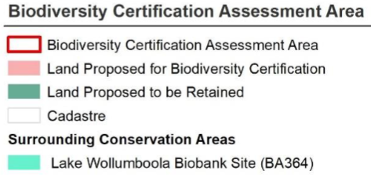
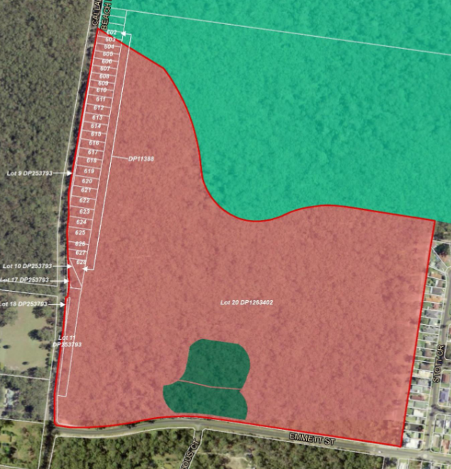
Figure 6: Biodiversity Certification Assessment Area
The PP will also facilitate the protection and conservation of 517 ha of land as part of the Lake Wollumboola BioBank site and bushland at Kinghorne. These lands are also identified as containing threatened species and its protection will deliver significant environmental benefits to the area.
The Biodiversity Certification Assessment forms part of the broader application to certify the development area under the provisions of the Biodiversity Conservation Act 2016. The Department’s Environment, Energy and Science (EES) division has previously provided input into the refinement of the assessment and broader Biodiversity Certification Application, confirming it is acceptable to be exhibited.
The Biodiversity Certification Assessment has undertaken initial consultation as outlined in Part 6 of this document and will be formally exhibited as part of the public exhibition of the PP.
As part of the public exhibition, EES will also be further consulted in accordance with Section 3.25 of the Act and with the Gateway determination.
Question 8 – Are there any other likely environmental effects as a result of the Planning Proposal and how are they proposed to be managed?
Water quality
The discharge of water from the development area has potential to increase the level of pollutants entering local drainage systems due to additional hard surfaces, changes to water movement and infiltration and the general use of land. Due to the proposed residential development, this impact is more likely to occur than if the land was to be retained wholly as bushland.
In addition, the Gateway determination identified water quality as a key issue to be considered further due to the potential impacts to the Jervis Bay Marine Park and local aquaculture leases. An Integrated Water Cycle Management Plan (Attachment N) has been prepared in support of the PP. The report identifies mitigation strategies such as the use of wetland areas and stormwater detention basins, in conjunction with other WSUD strategies are to be implemented at the time of development.
Stormwater modelling identified the proposed strategies as part of the masterplan for the development area can meet water quality standards as set by Council and by the Department. This includes the development delivering a neutral or beneficial impact on coastal water bodies, including the Jervis Bay Marine Park.
As part of the public exhibition, the Environmental Protection Agency, Department of Primary Industries – Fisheries Division and local oyster growers will be consulted in accordance with the Gateway determination.
Bushfire
As outlined in response to Ministerial Direction 4.3 Planning for Bushfire Protection, the subject land is wholly bushfire prone. The PP is supported by a Bushfire Hazard Assessment (Attachment K) which identifies mitigation strategies to reduce the impact associated with bushfire hazard. The assessment identifies the expansion of the development area west of the existing residential area will decrease the bushfire risk for the existing Callala Bay township.
The concept plan for the site also introduces an asset protection zone which serves to provide a buffer between development and bushland to reduce the risk of direct contact, damage or ember attack on the adjacent residential development.
The PP also proposes to map the site on the urban release area map which applies the provisions of Part 6 of the Shoalhaven LEP 2014. Under this part, clause 3 Development Control Plans will apply, which requires Council to prepare a site-specific DCP chapter related to the subject land prior to considering DAs for the site. Under this clause, the DCP is to include controls which seek to mitigate bushfire hazard risk, including the safe occupation of dwellings and evacuation from the site.
Table 4 also outlines matters which require resolution prior to the finalisation of this PP. These matters have been determined in consultation with NSW Rural Fire Service and the PP can proceed to public exhibition whilst these matters are investigated further. Further consultation of NSW Rural Fire Service will be completed in the public exhibition of the PP to determine any final refinements required to reduce the risk to life resulting from bushfire hazard.
Aboriginal heritage
The Jervis Bay area is of cultural significance to Aboriginal people, which includes the subject land. The PP will facilitate the conservation of approximately 517 ha of land at Callala Bay, Wollumboola and Kinghorne. This land is intended to ultimately form part of the Jervis Bay National Park. Working relationships regarding the management of the subject land and the Jervis Bay National Park will be explored by National Parks and Wildlife Service at the time when the land is transferred in ownership.
As noted in response to Ministerial Direction 3.2 Heritage Conservation, Aboriginal Cultural Heritage Assessment (Attachment J) and Archaeological reports (Attachment I) were prepared in support of the PP. These reports focus on the potential impact of land proposed to be rezoned for residential purposes. These reports identified recommendations to be in place prior to any development occurring, including protocols for any discovery of Aboriginal objects or Aboriginal ancestral remains. Additionally, continued consultation with registered Aboriginal parties is recommended as it relates to the management of Aboriginal cultural heritage on the subject land.
Jerrinja LALC will be engaged further during the public exhibition of this PP to provide comment and recommendations on the protection and recognition of Aboriginal heritage.
Traffic
The PP seeks to facilitate residential development to the west of the existing Callala Bay township, delivering new local roads as part of a residential subdivision. The proposed development, in accordance with the masterplan, will be accessed from a local road (Emmett Street) to the south. Vehicular traffic will primarily utilise this access point to travel to and from the main town centre. Primary access to the Princes Highway via Forest Road and Callala Beach Road will also be a source and contributor to local traffic conditions.
A traffic impact assessment (Attachment O) has been completed in support of the PP due to the potential increase in vehicular traffic on the local road network (including added congestion). This assessment has been informed by the requirements set under Council’s DCP. The assessment concludes the proposed development is not likely to create any adverse traffic impacts on the surrounding road network.
Opportunities for walking and cycling are also proposed as part of the broader development of the subdivision which will be refined as part of a future DA.
Transport for NSW will also be provided the opportunity to comment on the PP and associated technical studies during the public exhibition.
Question 9 – Has the Planning Proposal adequately addressed any social and economic effects?
The PP will provide positive social and economic outcomes by facilitating additional housing opportunities (approximately 370-380 new homes), supporting the local economy and providing new job opportunities. An infrastructure assessment (Attachment M) supporting the PP identifies the proposed residential area will utilise existing community infrastructure and public open space located in the existing subdivision to the east of the development area. The PP will also facilitate the provision of a local park and walking paths in conjunction with the bushland to be protected in the southern portion of the site.
The PP is supported by a letter of offer from the proponent to Council which outlines a draft planning agreement for the delivery of the above public open space to be provided by the proponent as well as additional linear open space connecting the development area to Jervis Bay through walking and cycling paths.

Section D – State or Commonwealth interests
Question 10 – Is there adequate public infrastructure for the Planning Proposal?
The proponent’s Infrastructure Assessment (Attachment M) indicates that adequate public infrastructure exists (or can be delivered) to meet demand generated by the proposed development. This includes the local road network, as well as energy, water and sewer connections.
As outlined in response to Question, 9, there is sufficient provision for additional public open space to be delivered as part of this PP. Similarly, the existing Callala Bay township includes a number of community resources including community halls and public open space which will be utilised by future residents.
The residential area will also be mapped as an Urban Release Area in the Shoalhaven LEP 2014, to which Part 6 applies. Part 6 requires that arrangements for the provision of adequate public utility infrastructure must be in place before the land can be subdivided.
Question 11 – What are the views of state and Commonwealth public authorities consulted in accordance with the Gateway determination?
Commonwealth agencies and public authorities
Prior to public exhibition, the Commonwealth Department of Agriculture, Water and Environment was consulted by Council, which approved an application to enable the proposed residential uses under the Environmental Protection and Biodiversity Conservation Act 1999. This application considered matters of environmental significance, specifically related to threatened and endangered species as assessed under the supporting Biodiversity Certification Assessment (Attachment H). The Commonwealth Department of Agriculture, Water and Environment is not proposed to be consulted further on the nature of the PP.
State agencies and public authorities
Consultation with the NSW Rural Fire Service has been completed prior to public exhibition in accordance with Ministerial Direction 4.3 Planning for Bushfire Protection. As outlined in response to Question 6, the comments from NSW Rural Fire Service have been considered and will be appropriately resolved prior to the finalisation of this PP.
The Department of Primary Industries – Fisheries Division has also provided comment on the proponent’s integrated Water Cycle Management Plan (Attachment N) prior to public exhibition. These comments have been responded to in Attachment N and have informed subsequent refinements to the plan.
EES has also been consulted prior to public exhibition in accordance with the Biodiversity Certification Assessment (Attachment H) which is being exhibited as part of this PP. Advice from EES has confirmed the Assessment is suitable for public exhibition and will be finalised separately to the PP in accordance with the requirements of the Biodiversity Conservation Act 2016.
Formal consultation with the following public agencies will be completed as part of the public exhibition in accordance with the Gateway determination:
- NSW Rural Fire Service;
- Transport for NSW (Former Roads and Maritime Services);
- EES (Former Office of Environment and Heritage);
- Heritage NSW (Former Office of Environment and Heritage);
- Department of Primary Industries; and
- Environment Protection Authority.

Shoalhaven Water and Endeavour Energy are also proposed to be consulted further to confirm the capacity to service the proposed residential development as outlined in the Infrastructure Assessment (Attachment M).
Jerrinja LALC and the Department of Education is also proposed to be engaged as part of the public exhibition of the PP.

Part 4 – Mapping
The following map tiles of the Shoalhaven LEP 2014 are proposed to be amended as outlined in response to Part 2, as part of this PP:
- Land Zoning Map – Sheets LZN_20E, LZN_20F, and LZN_20I
- Height of Building Map – Sheet HOB_20F
- Minimum Lot Size Map – Sheets LSZ_20E, LSZ_20F, and LSZ_20I
- Acid Sulfate Soils Map – Sheet ASS_20
- Terrestrial Biodiversity Map – Sheets BIO_20E, BIO_20F, and BIO_20I
- Riparian Lands and Watercourses Map – Sheets WCL_20E, WCL_20F, and WCL_20I
- Clauses Map – Sheets CLS_20E, CLS_20F, CLS_20I
- Urban Release Area Map – Sheet URA_20
- Land Application Map – Sheet LAP_001
Suitable LEP maps will be prepared to meet the Department’s technical mapping requirements, prior to the finalisation of the PP. The following figures highlight the proposed changes in mapping controls.

A4 size explanatory maps have been provided in Attachment B.

Part 5 – Community consultation

Consultation undertaken to date
Community consultation undertaken by Council to date on the PP and associated processes includes:
- A project specific webpage on Council’s ‘Get Involved’ engagement platform (https://getinvolved.shoalhaven.nsw.gov.au/halloran-trust-callala-kinghorne-pt);
- Key Stakeholders including the Community Consultative Bodies, Jerrinja Local Aboriginal Land Council and registered subscribers have been notified in writing of key milestones in the project so far (e.g. of Council reports and decisions); and
- The original larger PP (which included the additional Culburra Halloran Lands) was placed on preliminary public exhibition from 13 August 2014 to 5 September 2014, prior to the matter being reported to Council for a resolution to proceed. 141 written submissions were received, with 88 in support and 53 in opposition.
Some limited consultation was completed from 27 January 2020 to 9 February 2020 as part of the assessment process under the Commonwealth’s Environment Protection and Biodiversity Conservation Act 1999 (EPBC Act). Further details can be found at: http://epbcnotices.environment.gov.au/publicnoticesreferrals/

Formal public exhibition of the Planning Proposal
The Gateway determination requires a minimum 60 day public exhibition period for the PP. The PP will be exhibited from 14 April 2022 to 17 June 2022.
The Planning Secretary of the Department has been appointed as the Alternate Planning Proposal Authority (PPA) and will manage the public exhibition of the PP in conjunction with Council.
As part of the public exhibition, the Department and Council will notify landowners, the broader community and relevant State agencies inviting comment on the PP through mail, updates to Council’s Get Involved project page and the NSW Planning Portal.
The Department and Council will provide the opportunity for the community to ask questions on the PP and the Biodiversity Certification Assessment (Attachment H) through a webinar and a community ‘drop in’ session(s) during the public exhibition.
The Department and Council will also undertake consultation activities with the Jerrinja Local Aboriginal Land Council and local Aquaculture growers as outlined by the Gateway Determination.
Following the completion of public exhibition, the Department, along with Council, will review, summarise and respond to public submissions in a ‘submissions report’ which will be uploaded to the NSW Planning Portal.
The Department notes the Biodiversity Certification Assessment and Agreement applying to the subject land will be exhibited concurrently with the PP in accordance with the requirements under the Biodiversity Conservation Act 2016.
Submissions must be lodged by close of business on 17 June 2022 and must include:
- if the submission relates to the PP or the Biodiversity Certification Assessment, or both;
- a statement on whether the PP and/or the Biodiversity Certification Assessment is supported or objected to; and
- the reasons why the PP and/or the Biodiversity Certification Assessment is supported or objected to.

Part 6 – Project timeline
The following table outlines the timeline for the PP since the issuance of Gateway determination:
Table 5 – Project Timeline
Task | Timeframe
Commencement date (date of Gateway determination) | 13 June 2018
Gateway alteration to extend the timeframe to complete the PP | 18 June 2020
Completion of specialist studies | 4 February 2022
Consultation with government agencies (pre-exhibition) | 11 February 2022
Engagement of government agencies (during exhibition) | 14 April 2022 – 17 June 2022
Public exhibition (minimum 60 days) | 14 April 2022 – 17 June 2022
Consideration of public submissions | June – July 2022
Post exhibition consideration of PP (incl. any changes) | June – July 2022
Finalisation and notification of Plan | July - August 2022

Attachments
Attachment | Document
A | List of properties affected by this PP
B | Proposed mapping amendments – Part 4
C | Gateway determination
D | Gateway Alteration
E | List of SEPPs
F | List of Section 9.1 Ministerial Directions
G | Approval under the Environmental Protection and Biodiversity Conservation Act 1999
H | Biodiversity Certification Assessment
I | Archaeological Assessment Report
J | Aboriginal Cultural Heritage Assessment Report
K | Bushfire Hazard Study
L | Contamination Assessment
M | Infrastructure Assessment
N | Integrated Water Cycle Management Plan
O | Traffic Impact Assessment
P | Letter of offer to support a Planning Agreement
Q | Proponent’s masterplan for the development area
R | Pre-exhibition advice from NSW Rural Fire Service No. 1 dated 7 February 2022
S | Pre-exhibition advice from NSW Rural Fire Service No. 2 dated 14 March 2022
T | Proponent response to NSW Rural Fire Service advice dated 7 March 2022
U | Ecological Letter of support - Callala Bay Masterplan and Biocertification Assessment -Master Plan Amendments January 2021

